**Maven Project Creation Steps**

**By**

**Apparao Gongada**

**Steps to create the Parent Project:**

Step1: Open STS

Step2: Click File🡪 New🡪Maven🡪 Maven Project 🡪Next

Step3: Select check box Create a simple project (Skip archetype selection)

Step4: Click “Next”

Step5: Provide the Group Id, Artifact Id, and select packaging as pom

(For Example Artifact Id = Maponic.Modules)

Step6: click “Finish” button.

**Steps to create the child (or jar) projects:**

Step1: Right click on Parent project created on the above.

Step2: select the new maven project 🡪 and select “Maven Module” 🡪 “Next”

Step3: Select check box Create a simple project (Skip archetype selection)

Step4: Provide the Module Name (For Example Maponic.Service)

Step5: Click “Next” button

Step6: Select the Packaging as “jar”

Step7: Click on “Finish”

**Steps to create the web project (or war ) :**

Step1: Right click on Parent project created on the above.

Step2: select the new maven project 🡪 and select “Maven Module” 🡪 “Next”

Step3: Provide the Module Name (For example Maponic.Web)

Step4: Click “Next”

Step5: In Filter Text box type “web” , it will show the following screen.

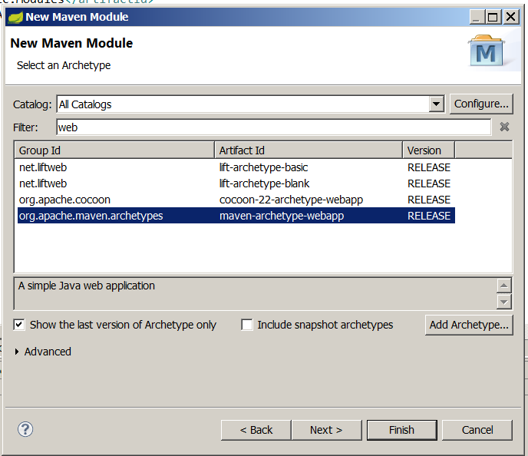

Step6: Select Group Id row , where value equal to “**org.apache.maven.archetypes**”

Step7: Click “Next”

Step8: Click on “Finish” project

**Steps to Checks the All dependency projects are working or not.**

Step1: Run the Maven clean command on “Parent project”

Step2: Run the Maven install command on “Parent project”

Step3: Based on your requirements add the dependencies jars to corresponding pom.xml files.